Evangadi Forum project Task breakdown

Note: The task number does not indicate task precedence.

***Backend Task***

**1. Title: Create MySQL Database and Table Schema for Q&A Evangadi Forum Platform**

Description: Set up the MySQL database structure and schema for the Q&A Evangadi Forum platform to facilitate question and answer interactions among users.

Acceptance Criteria:

* Database Setup:
  + MySQL server should be installed and accessible.
  + Execute CREATE DATABASE evangadi_forum; SQL command successfully.
  + Verify database creation by listing databases .
* Table Schema Creation:
  + Design tables: userTable, questionTabel , answerTable. Define fields and data types for each table to support Q&A functionalities.
  + Establish relationships between tables using foreign keys where applicable.
  + Include necessary constraints (e.g., primary keys, unique constraints).
* Schema Optimization:(This is optional only if you add more features)
  + Normalize tables to reduce redundancy and improve efficiency.
  + Consider indexing for performance optimization, especially for frequently queried fields.
* Database Configuration::
  + Create config,js or equivalent configuration file with MySQL connection details.
  + Ensure the configuration file accurately reflects MySQL connection parameters.
  + Verify successful database connectivity using the configured connection details.

Label: Database, Q&A Platform, MySQL

Dependency:

Task Points: 3days

Assignee: [ ]

**2. Title: API Documentation Tasks for Evangadi Forum**

Description: Document APIs for Evangadi Forum covering authentication, login, signup, and Q&A functionalities.

Acceptance Criteria:

1. Authentication Middleware:
   * Document the endpoint and method for authenticating users.
   * Specify required headers or parameters for authentication.
   * Describe the expected behavior and response status codes (e.g., 200 OK, 401 Unauthorized).
2. Sign-up:
   * Document the endpoint and method for user registration (signup).
   * Specify required fields ( username, first_name, last_name, email, password) in the request body.
   * Describe the expected behavior and response status codes (e.g., 201 Created, 400 Bad Request).
3. Login:
   * Document the endpoint and method for user login.
   * Specify required credentials ( email, password) in the request body.
   * Describe the expected behavior and response status codes (e.g., 200 OK, 401 Unauthorized).
4. Get Answers for a Question:
   * Document the endpoint and method to retrieve answers for a specific question.
   * Include query parameters or path variables if applicable.
   * Describe the response format and possible status codes (e.g., 200 OK, 404 Not Found).
5. Post Answers for a Question:
   * Document the endpoint and method to submit an answer for a question.
   * Describe the expected response format and status codes (e.g., 201 Created, 400 Bad Request).
6. Get All Questions:
   * Document the endpoint and method to fetch all questions.
   * Describe the response format and possible status codes (e.g., 200 OK, 404 Not Found).
7. Get Single Question:
   * Document the endpoint and method to retrieve details of a specific question.
   * Specify path variables or query parameters.
   * Describe the response format and possible status codes (e.g., 200 OK, 404 Not Found).
8. Post Question:
   * Document the endpoint and method to create a new question.
   * Describe the expected response format and status codes (e.g., 201 Created, 400 Bad Request).

Label: API Documentation

Task Points: 3 days

Assignee: [ ]

**3. Title: Implement Authentication Middleware**

Description: Develop authentication middleware to verify user identity and authorize access to protected endpoints.

**Endpoint**: /api/checkUser

Acceptance Criteria:

1. Middleware Implementation:
   * Create middleware to intercept requests and validate session tokens or credentials.
2. Token Verification:
   * Implement logic to verify JWT (JSON Web Token) or session tokens.
3. Error Handling:
   * Implement error handling for invalid or expired tokens (401 Unauthorized).
4. Security Considerations:
   * Implement HTTPS to protect token transmission and sensitive user data.

Label: API Development, Authentication, Middleware

Task Points: 3 days

Attachments:

* [Link to API documentation]

Assignee:[ ]

**4. Title: Implement Sign-up API Endpoint**

Description: Develop the Sign-up API endpoint to register new users with username, first name, last name, email, and password.

**Endpoint**: /api/register

Acceptance Criteria:

1. Endpoint Implementation:
   * Create the /api/register endpoint using the HTTP POST method.
2. Request Parameters:
   * Define required fields in the request body:
     + username: (string, required) Unique username for the user.
     + first_name: (string, required) First name of the user.
     + last_name: (string, required) Last name of the user.
     + email: (string, required) Email address of the user.
     + password: (string, required) Password for the user account.
3. User Registration Logic:
   * Implement validation and storage logic for the provided user details.
4. Password Security:
   * Implement secure password hashing (e.g., bcrypt) before storing in the database.
5. Response Handling:
   * Handle responses for successful user creation (201 Created) and validation errors (400 Bad Request).
6. Error Handling:
   * Implement error handling for missing or invalid request parameters.
   * Check for existing users with the same username or email to prevent duplicates.

Label: API Development, Authentication, Sign-up

Task Points: 3 days

Attachments:

* [Link to API documentation ]

Assignee: [ ]

**5.Title: Implement Login API Endpoint**

Description: Develop the Login API endpoint to authenticate users and issue session tokens for accessing protected resources.

**Endpoint**: /api/login

Acceptance Criteria:

1. Endpoint Implementation:
   * Create the /api/login endpoint using the HTTP POST method.
2. Authentication Logic:
   * Implement logic to validate user credentials (email and password).
3. Session Token Generation:
   * Generate a session token (JWT) upon successful authentication.
4. Response Handling:
   * Handle responses for successful authentication (200 OK) and invalid credentials (401 Unauthorized).
5. Error Handling:
   * Implement error handling for missing or invalid request parameters (Follow api doc).
6. Security Considerations:
   * Ensure sensitive information (e.g., passwords) is securely handled and transmitted over HTTPS.

Label: API Development, Authentication, Login-in

Task Points: 3 days

Attachments:

* [Link to API documentation ]

Assignee: [ ]

**6. Title: Implement API Endpoint: Get Answers for a Question**

Description: Develop the API endpoint to retrieve answers for a specific question.

**Endpoint**: api/answer/:question_id

Acceptance Criteria:

1. Endpoint Implementation:
   * Create the /api/answer /:question_id endpoint using the HTTP GET method.
2. Request Parameters:
   * Define path variable question_id to specify the question for which answers are requested.
3. Response Handling:
   * Handle responses with JSON payload containing answers and associated metadata.
4. Error Handling:
   * Implement error handling for invalid question_id or other client errors (Follow api doc).

Label: API Development, Get Answers, Question

Task Points: 3 days

Attachments:

* [Link to API documentation ]

Assignee: [ ]

**7. Title: Implement API Endpoint: Post Answers for a Question**

Description: Develop the API endpoint to post an answer for a specific question.

**Endpoint**: api/answer

Acceptance Criteria:

1. Endpoint Implementation:
   * Create the /api/answer endpoint using the HTTP POST method.
2. Response Handling:
   * Handle responses for successful answer creation (201 Created) and validation errors (Follow api doc).
3. Error Handling:
   * Implement error handling for missing answers.

Label: API Development, Post Answer, Question

TaskPoints: 3 days

Attachments:

* [Link to API documentation]

Assignee: [ ]

**8.Title: Implement API Endpoint: Get All Questions**

Description: Develop the API endpoint to fetch all questions.

**Endpoint**: api/question

Acceptance Criteria:

1. Endpoint Implementation:
   * Create the /api/question endpoint using the HTTP GET method.
2. Response Handling:
   * Handle responses with JSON payload containing all questions and associated metadata.
3. Error Handling:
   * Implement error handling for client errors (Follow api doc) or server errors (500 Internal Server Error).

Label: API Development, Get All Questions

TaskPoints: 4 days

Attachments:

* [Link to API documentation]

Assignee: [ ]

**9. Title: Implement API Endpoint: Get Single Question**

Description: Develop the API endpoint to retrieve details of a specific question.

**Endpoint**: api/question/:question_id

Acceptance Criteria:

1. Endpoint Implementation:
   * Create the api/question/:question_id endpoint using the HTTP GET method.
2. Request Parameters:
   * Define path variable question_id to specify the question ID for retrieval.
3. Response Handling:
   * Handle responses with JSON payload containing details of the question.
4. Error Handling:
   * Implement error handling for invalid question_id ( Not Found) or other client errors (Follow api doc).

Label: API Development, Get Single Question

Task Points: 3 days

Attachments:

* [Link to API documentation]

Assignee: [ ]

**10. Title: Implement API Endpoint: Post Question**

Description: Develop the API endpoint to create a new question.

**Endpoint**: api/question

Acceptance Criteria:

1. Endpoint Implementation:
   * Create the api/question endpoint using the HTTP POST method.
2. Response Handling:
   * Handle responses for successful question creation (201 Created) and validation errors (Follow api doc).
3. Error Handling:
   * Implement error handling for missing or invalid request parameters.

Label: API Development, Post Question

TaskPoints: 3 days

Attachments:

* [Link to API documentation]

Assignee: [ ]

***Frontend Task***

**11. Title: Implement Header Component**

Description: Develop the Header component for the Evangadi Forum application, including navigation links.

Acceptance Criteria:

1. Component Structure:
   * Create the Header component structure with navigation links (Home, LogOut LogIn).
2. Styling:
   * Apply CSS styles to ensure a responsive and visually appealing header.
3. Routing:
   * Implement navigation links to route to corresponding pages.

4. LogOut functionality

Label: Frontend Development, Header

Attachments: use the below screenshot attachment.





TaskPoints: 2 days

Assignee: [ ]

**12. Title: Implement Footer Component**

Description: Develop the Footer component for the Evangadi Forum application, including site links and contact information.

Acceptance Criteria:

1. Component Structure:
   * Create the Footer component structure with site links (Useful Link,Contact Info and Socials)
2. Styling:
   * Apply CSS styles to ensure a responsive and visually appealing footer.

Label: Frontend Development, Footer

Attachments: use the below screenshot attachment.



Task Points: 2 days

Assignee: [ ]

**13. Title: Implement Sign-up Component**

Description: Develop the Sign-up component for the Evangadi Forum application to register new users.

Acceptance Criteria:

1. Component Structure:
   * Create the Sign-up component with form fields (username, first name, last name, email, password).
2. Form Validation:
   * Implement form validation to ensure all fields are correctly filled out.
3. API Integration:
   * Integrate with the Sign-up API to submit user registration details.
4. Styling:
   * Apply CSS styles for a user-friendly and responsive form.

Label: Frontend Development, Sign-up

Attachments: use the below screenshot attachment.

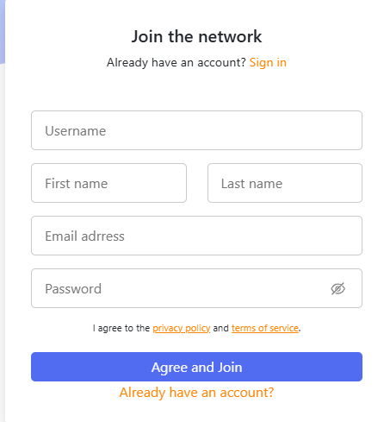

TaskPoints: 2days

Assignee: [ ]

**14. Title: Implement Login-in Component**

Description: Develop the Sign-in component for the Evangadi Forum application to authenticate users.

Acceptance Criteria:

1. Component Structure:
   * Create the Sign-in component with form fields (email, password).
2. Form Validation:
   * Implement form validation to ensure all fields are correctly filled out.
3. API Integration:
   * Integrate with the Login API to authenticate users.
4. Styling:
   * Apply CSS styles for a user-friendly and responsive form.

Label: Frontend Development, Sign-in

Attachments: use the below screenshot attachment.

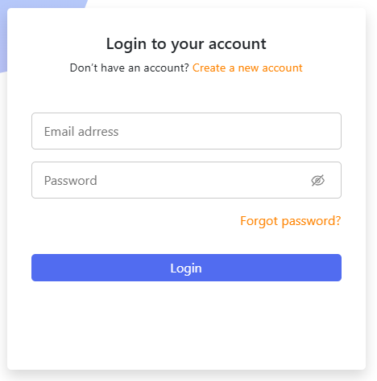

TaskPoints: 3 days

Assignee: [ ]

**15. Title: Implement About Component**

Description: Develop the About component for the Evangadi Forum application to provide information about the platform.

Acceptance Criteria:

1. Component Structure:
   * Create the About component with information about Evangadi Network.
2. Styling:
   * Apply CSS styles to ensure a visually appealing and responsive layout.
3. Content Integration:
   * Add content such as text, and links.

Label: Frontend Development, About

Attachments: use the below screenshot attachment.



TaskPoints: 2 days

Assignee [ ]

**16. Title: Implement Sign-up and Sign-in Page**

Description: Develop the Sign-up and Sign-in page for the Evangadi Forum application to allow users to register and log in.

Acceptance Criteria:

1. Page Structure:
   * Create the Sign-up and Sign-in page with navigation between the Sign-up and Sign-in components.
2. Component Integration:
   * Integrate the Sign-up and Sign-in components on the page.
3. Styling:
   * Apply CSS styles for a consistent and user-friendly design.

Label: Frontend Development, Sign-up, Sign-in

Attachments: use the below screenshot attachment.

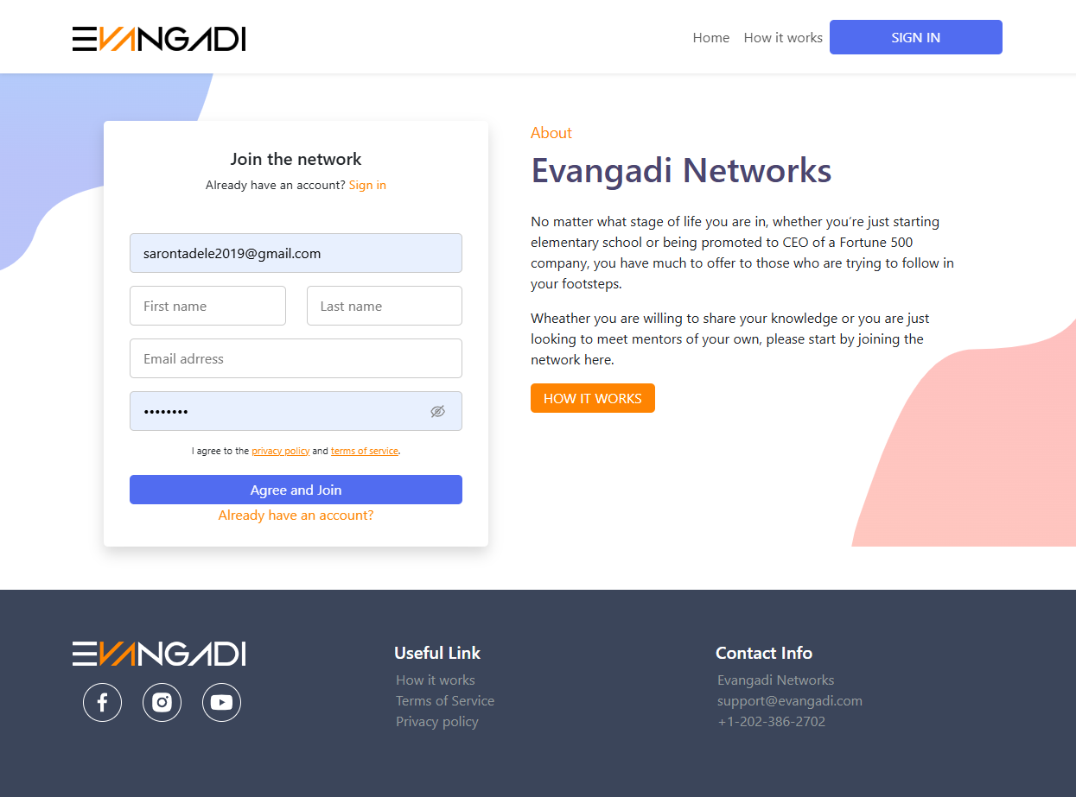

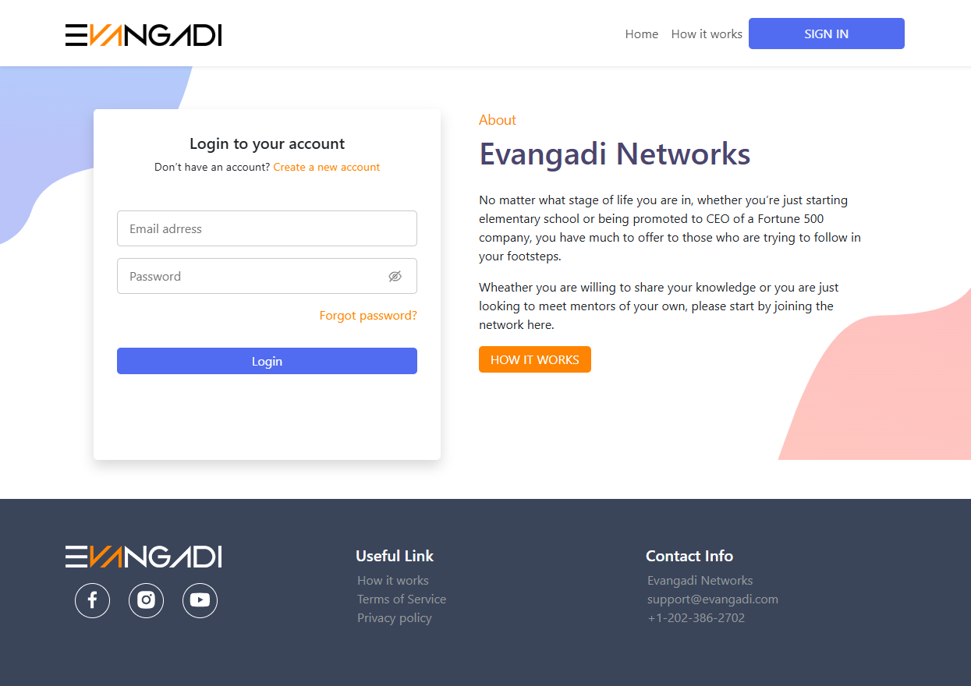

Task Points: 2 days

Assignee: [ ]

**17. Title: Implement Home Page**

Description: Develop the Home page for the Evangadi Forum application, serving as the landing page for users.

Acceptance Criteria:

1. Page Structure:
   * Create the Home page.
2. API Integration
3. Styling:
   * Apply CSS styles to ensure a visually appealing and responsive layout.

Label: Frontend Development, Home

Attachments: use the below screenshot attachment. 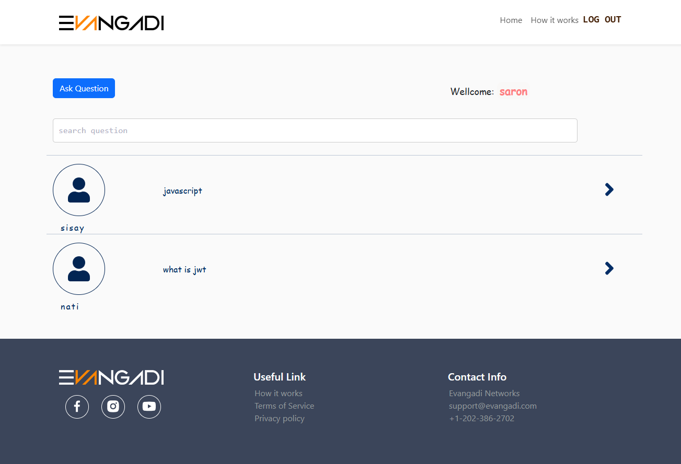

TaskPoints: 3 days

Assignee: [ ]

**18. Title: Implement Question Page**

Description: Develop the Question page for the Evangadi Forum application to display details of a specific question.

Acceptance Criteria:

1. Page Structure:
   * Create the Question page with sections for the question, answers, and answer form.
2. API Integration
3. Content Display:
   * Display question details and list of answers.
4. Answer Submission:
   * Include a form for submitting new answers.
5. Styling:
   * Apply CSS styles to ensure a visually appealing and responsive layout.

Label: Frontend Development, Question

Attachments: use the below screenshot attachment.

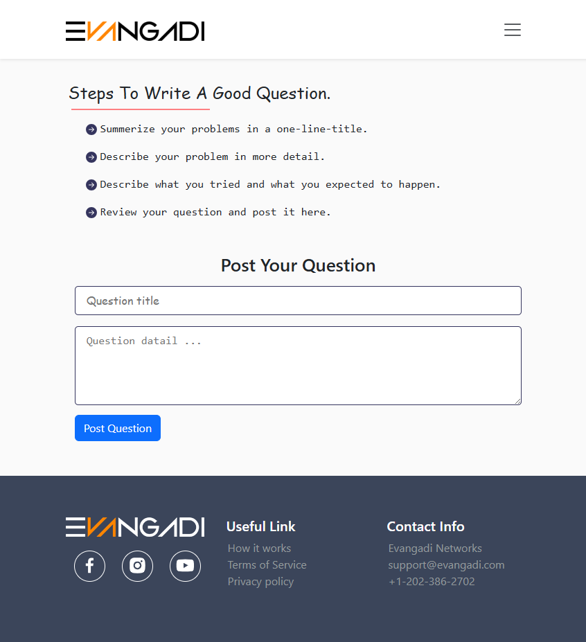

Task Points: 3 days

Assignee: [ ]

**19. Title: Implement Answer Page**

Description: Develop the Answer page for the Evangadi Forum application to display and submit answers to questions.

Acceptance Criteria:

1. Page Structure:
   * Create the Answer page with sections for the question, answers, and answer form.
2. API Integration
3. Content Display:
   * Display the question and existing answers.
4. Answer Submission:
   * Include a form for submitting new answers.
5. Styling:
   * Apply CSS styles to ensure a visually appealing and responsive layout.

Label: Frontend Development, Answer

Attachment: use the below screenshot attachment. 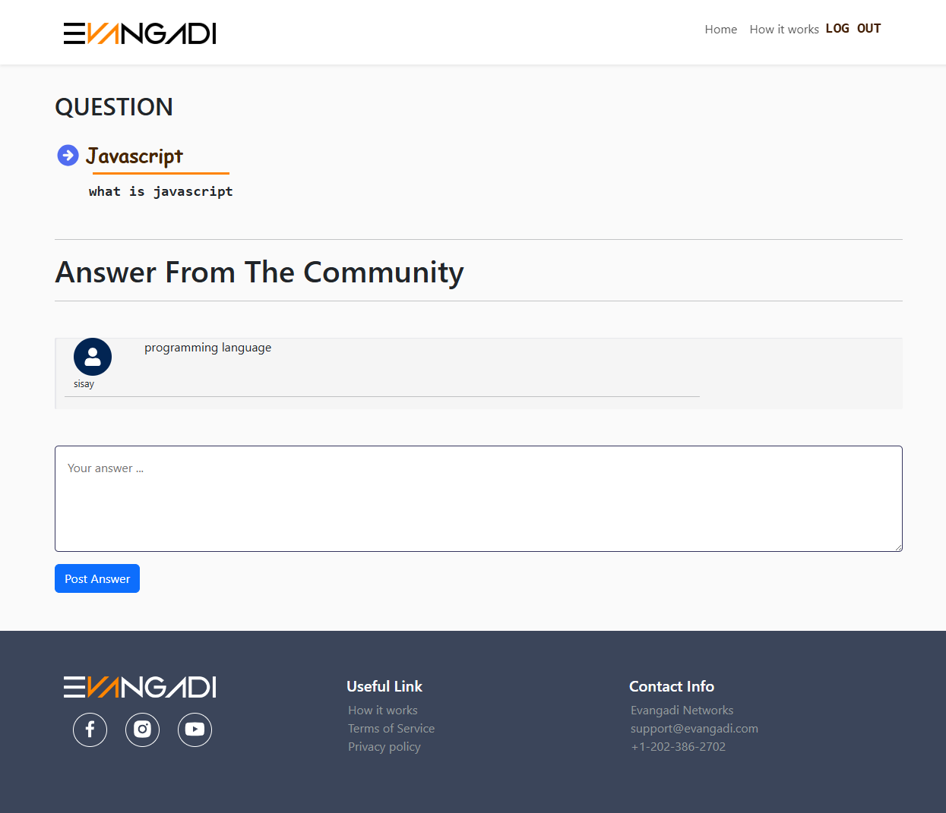

Task Points: 3days

Assignee: [ ]